YILDIZ TECHNICAL UNIVERSITY

Smart Insole

Working with strain gauges /load cell/ force sensors (design, implementation proposal, and calibration)

Names And ID’s:

Aylin Bakkal 22016042

Taima Makhlouf 22016929

Hagar Hussein 22016936

12/25/2023

KOM2731 Measurements and Sensors

**Introduction**

In the world of childhood growth, a child's manner of walking can supply valuable clues to their overall health. Tiptoe walking, a common occurrence where children walk exclusively on their toes can stem from a range of factors including muscle tightness, neurological disorders, and sensory challenges. This project delves into comprehending and addressing this unique gait, examining its multifaceted origins, and presenting interventions to support children in their developmental progress.

Idiopathic toe walking (ITW) is a pathological gait pattern in which children walk on their tiptoes for no orthopedic or neurological reason. This project specifically focuses on using innovative technology, namely the Smart Insole, to aid children and their parents on their physiotherapy journey. By targeting ITW with a technological intervention, we aim to supply a holistic approach to early detection and intervention, promoting the well-being and musculoskeletal health of children.

**Problem approach/Design**

This section outlines the design approach to create a supportive insole that aids in the management of ITW, focusing on simplicity and effectiveness for both children and their caregivers.

Despite its prevalence, tiptoe walking often goes unnoticed or is dismissed due to its subtle nature. Parents and caregivers may face challenges in recognizing this behavior early on, leading to delayed intervention. The intricacies of tiptoe walking demand a heightened awareness to ensure prompt identification and proper measures.

According to recent studies, In Sweden, it was found that prevalence of idiopathic toe-walking to approximately 5% (63 out of 1,401) between the ages of 5.5 and 8 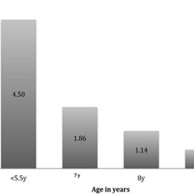

The data shows that children under the age of 5.5 face more challenges with this issue. Notably, a crucial aspect concerning children in this age group is the majority of them are non-verbal

Early intervention plays a pivotal role in mitigating the potential consequences associated with tiptoe walking. The challenge lies in the ability to show and differentiate between various causes, especially when addressing idiopathic toe walking (ITW). ITW refers to a pathological gait pattern where children walk on their tiptoes without any orthopedic or neurological explanation.

**The Design**

The primary goal is to develop a Smart Insole that serves as an innovative and non-intrusive tool for early detection and intervention in children showing idiopathic toe walking (ITW).

The smart insole is designed with simplicity in mind, aiming for easy integration into a child's daily routine. There are no need for external feedback mechanisms to avoid overwhelming the child, only LED indicators connected to digital output pins for immediate visual feedback. colorful elements were used to keep children's interest and attention

About the system elements, we used a load cell,HX711 Amplifier, ArduinoBoard, and LED Indicators. The load cell serves as the primary sensor, measuring the pressure exerted on the insole during walking, and The HX711 amplifier plays a vital role in the system by converting analog signals from the load cell into digital data, of course the Arduino board serves as the brain of the Smart Insole system

About the plan that been followed:

1. **Background Research:**

Smart insoles have gained traction in various applications, ranging from sports performance monitoring to healthcare. These solutions often incorporate pressure sensors, accelerometers, and gyroscopes to check gait, step count, and even balance. During the background research it shows that In healthcare, smart insoles have shown promise in monitoring and managing conditions such as diabetic foot ulcers and gait abnormalities, but they also not cover the Idiopathic toe walking even to some it might be not a series condition that why the deep research helped build the importance of this project.

1. **Target Audience Identification**

This part of the plan that took the most. So much research and feedback are needed for this project to grantee that it will be helpful to the targeted audience. Which are mostly kids who have tight calf muscles, neurological conditions, sensory issues, autism spectrum disorder, or idiopathic factors.

1. **Scope and Limitations**

Many difficulties have been faced and limitations to make it more beginners friendly. As beginners in the field, access to advanced resources and tools was limited due to the complexity of the project and the range of features that could be implemented.

And the skill difference between the teammates limited the complexity of certain functionalities. Balancing the complexity of the technology with user-friendliness was a continuous challenge

1. **Milestones of the project**

### **Research and Planning**

* Conduct a comprehensive review of existing smart insole technologies.
* Define project objectives, features, and user requirements.
* Plan the technological stack and select components based on beginner-friendly criteria.

### **Component Acquisition and Prototyping :**

* Purchase necessary components within the project budget.
* Begin the prototyping phase, assembling and testing individual components.
* Evaluate the feasibility of integrating selected sensors and microcontrollers.

### **Basic Functionality Implementation :**

* Develop the foundational code for reading pressure values from the load cell.
* Implement a basic user interface on the Arduino for data visualization.
* Test the initial prototype for accuracy and reliability.

### **Calibration and Accuracy :**

* Develop a calibration process for the load cell to enhance accuracy.
* Implement algorithms to compensate for variations in sensor readings.
* Conduct extensive testing to validate the accuracy of pressure measurements.

### **Final Testing and Iterative Refinement :**

* Conduct final testing with a diverse group of users.
* Gather feedback for iterative refinement of the smart insole's functionality.
* Address any remaining issues or challenges identified during testing.

### **Project Presentation and Report Writing :**

* Compile all project documentation, including research, design decisions, and codebase.
* Prepare a comprehensive project presentation for stakeholders.
* Write the final project report, highlighting achievements, challenges, and lessons learned.

# **2** - **Implementation**

2.1 System Design Implementation

2.1.1 Hardware

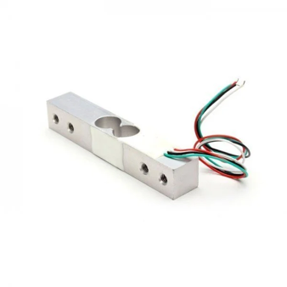  
Load Cell (HX711):

The load cell is a critical component responsible for measuring the weight applied to it. In this system, a 10 kg load cell is employed. The load cell converts the force (weight) applied to it into an electrical signal.

Arduino Uno:

The Arduino Uno serves as the microcontroller and central processing unit of the system. It interfaces with the load cell through the HX711 amplifier, reads the analog signals, and processes the data. The Arduino Uno also executes the programmed logic for calibration, measurements, and any control strategies.

HX711 Amplifier:

The HX711 is a precision 24-bit analog-to-digital converter (ADC) designed to interface with a load cell. It amplifies the low-level signals from the load cell and provides a stable and accurate digital output that the Arduino can process

Load cell platform:

**Load cell platform setup:**

The wires coming from the load cell usually have the following colors:

* Red: VCC (E+)
* Black: GND (E-)
* White: Output – (A-)
* Green: Output + (A+)

Schematic diagram to wire the load cell to the Arduino board:

|  |  |  |  |
| --- | --- | --- | --- |
| **Load Cell** | **HX711** | **HX711** | **Arduino** |
| **Red (E+)** | **E+** | **GND** | **GND** |
| **Black (E-)** | **E-** | **DT** | **Pin 2** |
| **White (A-)** | **A-** | **SCK** | **Pin 3** |
| **Green (A+)** | **A+** | **VCC** | **5V** |

Wiring Load Cell and HX711 Amplifier to the Arduino:

**2.1.2 Software**

Arduino IDE:

The software for the system is developed using the Arduino Integrated Development Environment (IDE). This includes the programming logic responsible for reading data from the HX711, calibrating the system, and implementing any control strategies.

MATLAB :

Matlab, short for MATrix LABoratory, is a high-level programming language and interactive environment primarily designed for numerical computing, data analysis, and visualization. Developed by MathWorks, Matlab is widely used in academia, industry, and research for a variety of applications, including engineering, physics, finance, signal processing, and more.

2.2 System Circuits and Programs

**System Calibration:**

Calibration is a process used to adjust or standardize a measurement system to ensure its accuracy and reliability. In the context of your weight measurement system using a load cell (HX711) and Arduino, calibration is crucial for obtaining accurate and precise weight measurements. Here's an explanation of the calibration process:

#include <Arduino.h>

#include "HX711.h"

// HX711 circuit wiring

const int LOADCELL_DOUT_PIN = 2;

const int LOADCELL_SCK_PIN = 3;

HX711 scale;

void setup() {

Serial.begin(57600);

Serial.println("HX711 Demo");

Serial.println("Initializing the scale");

scale.begin(LOADCELL_DOUT_PIN, LOADCELL_SCK_PIN);

Serial.println("Before setting up the scale:");

Serial.print("read: \t\t");

Serial.println(scale.read()); // print a raw reading from the ADC

Serial.print("read average: \t\t");

Serial.println(scale.read_average(20)); // print the average of 20 readings from the ADC

Serial.print("get value: \t\t");

Serial.println(scale.get_value(5)); // print the average of 5 readings from the ADC minus the tare weight (not set yet)

Serial.print("get units: \t\t");

Serial.println(scale.get_units(5), 1); // print the average of 5 readings from the ADC minus tare weight (not set) divided

// by the SCALE parameter (not set yet)

scale.set_scale(226.463);

//scale.set_scale(-471.497); // this value is obtained by calibrating the scale with known weights; see the README for details

scale.tare(); // reset the scale to 0

Serial.println("After setting up the scale:");

Serial.print("read: \t\t");

Serial.println(scale.read()); // print a raw reading from the ADC

Serial.print("read average: \t\t");

Serial.println(scale.read_average(20)); // print the average of 20 readings from the ADC

Serial.print("get value: \t\t");

Serial.println(scale.get_value(5)); // print the average of 5 readings from the ADC minus the tare weight, set with tare()

Serial.print("get units: \t\t");

Serial.println(scale.get_units(5), 1); // print the average of 5 readings from the ADC minus tare weight, divided

// by the SCALE parameter set with set_scale

Serial.println("Readings:");

}

void loop() {

Serial.print("one reading:\t");

Serial.print(scale.get_units(), 1);

Serial.print("\t| average:\t");

Serial.println(scale.get_units(10), 5);

delay(5000);

}

2.3 System Results:

Static Characteristics of the system:

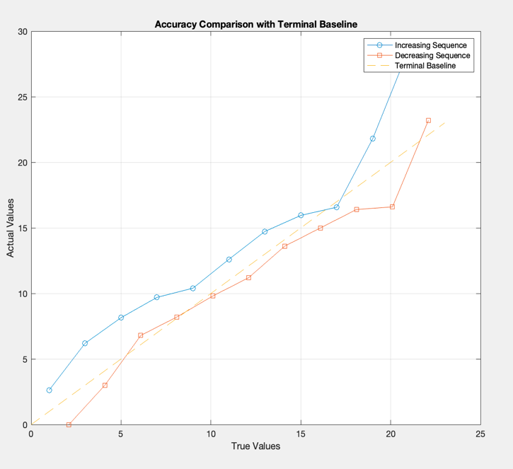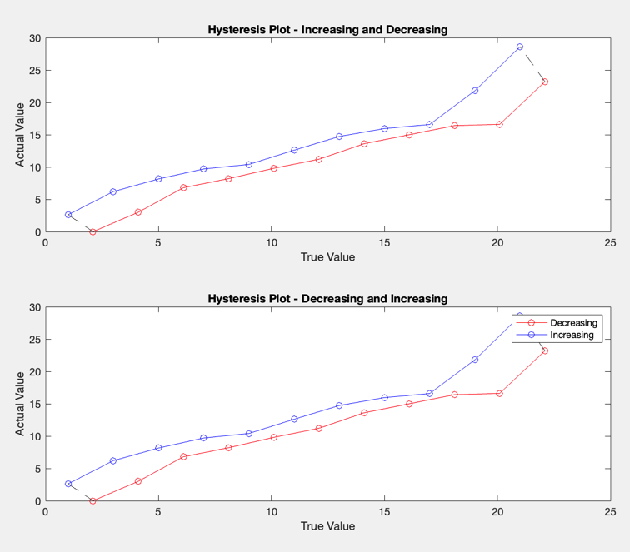Hysteresis : Accuracy :

Linearity:

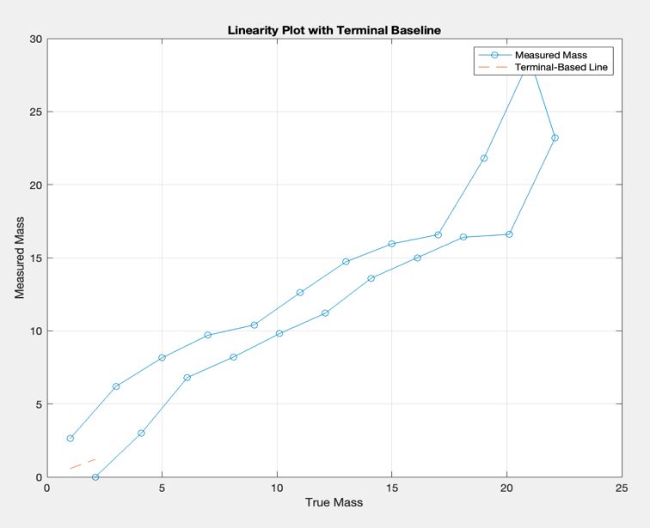

Parameter Calculations:

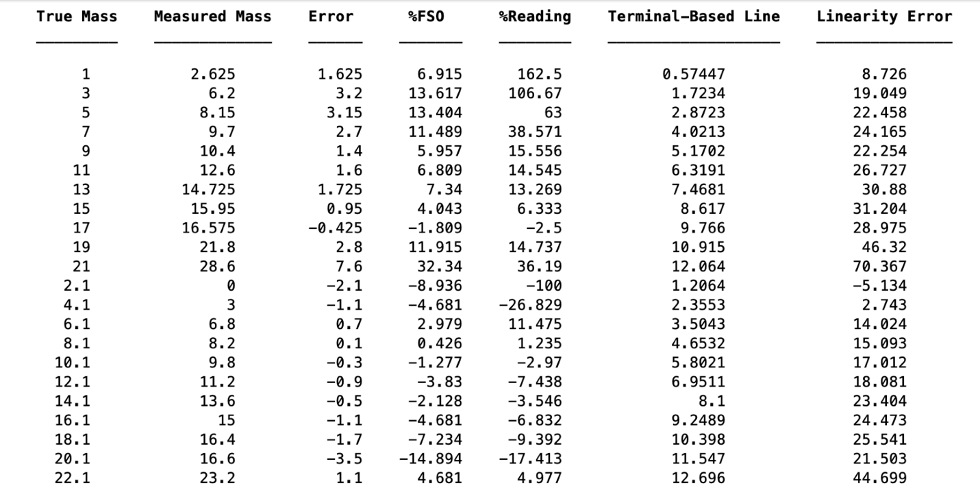

2.3.1 Error Analysis

Observed Errors and Discrepancies:

1. Zero Offset Error:
   * A noticeable zero offset error was observed during the zero calibration phase. Even when no weight was applied, there were non-zero readings from the load cell.
2. Non-Linearity in Measurements:
   * The system exhibited slight non-linearity, especially towards the upper range of the load cell. The measured values deviated slightly from the expected linear response.
3. Hysteresis Effects:
   * Hysteresis effects were observed, particularly during rapid changes in applied force. The system did not consistently return to the same zero reading after load removal, indicating a hysteresis loop.

Potential Sources of Error:

1. Load Cell Imperfections:
   * The zero offset error may arise from imperfections in the load cell itself, such as manufacturing tolerances or sensor drift. Calibrating the load cell more frequently may help mitigate this.
2. Environmental Factors:
   * Changes in temperature and humidity can affect the load cell's performance. Implementing temperature compensation techniques or housing the system in a controlled environment could reduce environmental influences.
3. Non-Ideal Mechanical Setup:
   * Mechanical components, such as the shoe insole or the way the load is applied, could introduce non-linearities. Ensuring a more uniform and controlled loading condition might improve linearity.
4. Hysteresis in Load Cell:
   * The observed hysteresis effects may be inherent to the load cell. Selecting a load cell with lower hysteresis characteristics or implementing algorithms to compensate for hysteresis could address this issue.

Strategies for Improvement:

1. Enhanced Calibration Procedures:
   * Implement a more robust calibration procedure that considers zero offset correction and gain adjustment over a broader range of conditions. This could involve calibrating the system at multiple points to capture non-linearities.
2. Advanced Filtering Techniques:
   * Apply advanced filtering techniques in the software to smooth out noisy readings and reduce the impact of sudden changes in force. Digital filtering can improve the stability of the measurements.
3. Regular Maintenance and Calibration:
   * Schedule regular maintenance and calibration sessions to address any drift or changes in the load cell's behavior over time. This proactive approach can maintain the system's accuracy.
4. Mechanical System Optimization:
   * Review and optimize the mechanical setup, including the attachment of the load cell to the insole and the overall design. Ensuring a more consistent loading condition may contribute to improved linearity.
5. Hysteresis Compensation Algorithm:
   * Develop and implement a hysteresis compensation algorithm in the software to dynamically adjust readings based on the previous loading history. This can minimize the effects of hysteresis in the load cell.

# Conclusion and Personal Comment

Reflecting on this project, it goes beyond just a technical venture; it's a blend of technology and empathy. We encountered challenges, but each obstacle became an opportunity to learn and refine our solution. Beyond the circuitry and code, this system is meticulously crafted to cater to the unique needs of children who walk on their tiptoes.

This project isn't solely about achieving precision and accuracy; it's about making a tangible difference in the lives of its users. As we wrap up testing, our hope is that this system evolves into a reliable companion for those it aims to assist. It's a reminder that innovation isn't confined to technology alone; it's about creating solutions that positively impact people's lives.

Another comment is this project really pushed us to improve our skills and challenge us to really take advantage of our abilities.

# Reference List

<https://mass4d.com/blogs/clinicians-blog/idiopathic-toe-walking>

<https://en.wikipedia.org/wiki/Toe_walking>

<https://www.youtube.com/watch?v=lWFiKMSB_4M&t=10s>

<https://www.youtube.com/watch?v=LRd3W_p8PJ4&t=423s>

<https://www.youtube.com/watch?v=uOtr681rxbw&t=411s>

<https://www.youtube.com/watch?v=LRd3W_p8PJ4&t=423s>

https://randomnerdtutorials.com/arduino-load-cell-hx711/